Design Pattern and Principles

# Exercise 01 – Implementing the Singleton pattern

Logger.java

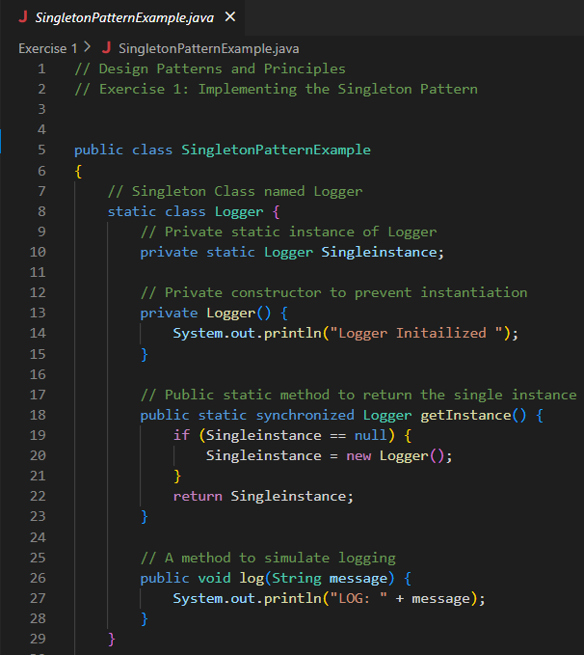

Main.java

Output:



# Exercise 02 – Implementing the Singleton pattern

Interface for all documents

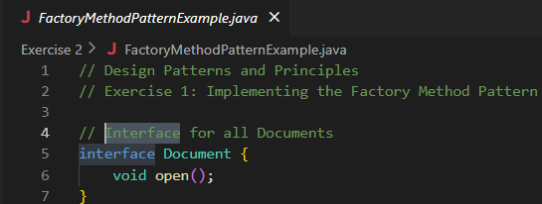

WordDocument.java

PDFDocument.java

ExcelDocument.java

Abstract Factory

WordDocumentFactory.java

PDFDocumentFactory.java

ExcelDocumentFactory.java

FactoryTest.java

